1 |  | Planning (P)  The following describes the preparation of methylamine hydrochloride, CH₃NH₃Cl from ethanamide, CH₃CONH₂. The equations involving the chemicals in the preparation are as shown:
 |  | CH₃CONH₂ + 4NaOH + Br₂ → CH₃NH₂ + Na₂CO₃ + 2NaBr + 2H₂O ……[1]
 |  | CH₃NH₂ + HCl → CH₃NH₃Cl ………….. [2]
 |  | The procedure in the preparation of methylamine, CH₃NH₂ is as follows:
 | 1. | Dissolve 36 g of sodium hydroxide, NaOH in 160 cm³ water contained in a 500 cm³ conical flask and chilled the stirred solution to 0-5° C in ice water.
 | 2. | Add 10.8 cm³ (32.4 g) of bromine to the stirred solution.
 | 3. | Add 12 g ethanamide, CH₃CONH₂ to the stirred bromite(I) solution.
 | 4. | Remove the conical flask containing the alkaline solution from the ice water and set it aside at room temperature for 30 minutes.
(a) |  | What is the purpose of using ice water?
………………………………………………………………………………………………

………………………………………………………………………………………………
 |  | [1]
(b) |  | What apparatus are used to measure out
 | (i) | 36 g NaOH ………………………………………………………………………………  160 cm³ …………………………………………………………………………………...  10.8 cm³ …………………………………………………………………………………...
 | (ii)
 | (iii)
 |  | [3]
(c) |  | The boiling point of CH₃NH₂ is 70° – 80° C. Draw the apparatus to collect CH₃NH₂ from the reaction mixture.
 |  | [4]
(d) |  | The last stage of reaction is to obtain colourless crystals of CH₃NH₃⁺Cl⁻. The procedure is as follows:
 | 1. | CH₃NH₂ is absorbed by hydrochloric acid in a beaker.
 | 2. | Transfer the resultant solution to a small evaporating dish and evaporate to dryness on a boiling water bath to obtain the crude dry solid.
 | (i) | Why is water bath used instead of direct heating?
 |  | ………………………………………………………………………………………………
 | (ii) | The crude dry solid from d(2) consists of CH₃NH₃⁺Cl⁻ with small amount of NH₄Cl. Suggest how you could purify CH₃NH₃⁺Cl⁻.
………………………………………………………………………………………………

………………………………………………………………………………………………

………………………………………………………………………………………………

………………………………………………………………………………………………

………………………………………………………………………………………………

………………………………………………………………………………………………

………………………………………………………………………………………………
 |  | [4]
 |  | [Total: 12]

2 |  | Many interhalogen compounds are very active oxidising agents as well as strong acids. Examples are oxoacids of chlorine, chloric(V) acid, HClO₃ and chloric(VII) acid, HClO₄.
(a) | (i) | With an aid of an equation, show HClO₃ as a strong Bronsted-Lowry monoprotic acid in an aqueous solution.
 |  | …………………………………………………………………………………………
 | (ii) | Explain why chloric(VII) is a stronger acid than chloric(V) acid in terms of their structures and bonding.
…………………………………………………………………………………………

…………………………………………………………………………………………

…………………………………………………………………………………………
 | (iii) | Draw the dot-cross diagram of HClO₃. Using VSEPR model, predict the shape with respect to Cl and indicate a possible O-Cl-O bond angle.
 |  | [6]
 |  | Labels on HClO₃ and HClO₄ accidentally dropped off. To identify them, a technician measures 1.268 g of each of the acids and an adequate solution of a green aqueous iron(II) sulfate solution is added until it turns yellow. To the resulting solution, 30 cm³ of 0.500 mol dm⁻³ of AgNO₃(aq) is needed for a white precipitate to form. This white precipitate dissolves in excess aqueous ammonia.
(b) | (i) | Identify the white precipitate.
 |  | …………………………………………………………………………………………
 | (ii) | Write an equation, including state symbols to show the solubility of the white precipitate in excess aqueous ammonia.
 |  | …………………………………………………………………………………………
 | (iii) | Identify the ion in the yellow solution and explain why it is coloured.
…………………………………………………………………………………………

…………………………………………………………………………………………

…………………………………………………………………………………………

…………………………………………………………………………………………

…………………………………………………………………………………………

…………………………………………………………………………………………
 | (iv) | Identify which of the chloric compounds gave the above result.
…………………………………………………………………………………………

…………………………………………………………………………………………

…………………………………………………………………………………………

…………………………………………………………………………………………
 |  | [10]
 |  | [Total: 16]
3 |  | Consider an equilibrium mixture,
 |  | 4NH₃(g) + 3O₂(g) 2N₂(g) + 6H₂O(g) ΔH = −1267 kJ mol ⁻¹
The graph below shows how the fraction of N₂(g) in the equilibrium mixture varies with temperature and pressure.

Fraction of N₂ in equilibrium mixture

P₁

temperature

(a) | (i) | Comment on the shape of the curve.
…………………………………………………………………………………………

…………………………………………………………………………………………

 | (ii) | On the same graph, sketch a curve to show how the fraction of N₂ changes at a higher pressure, P₂ .
 |  | [3]
(b) |  | An initial 5 moles of NH₃ and 3 moles of O₂ are mixed in a 2 dm³ vessel. At 450° C, an equilibrium mixture shows 80% of ammonia has reacted . Calculate a value for the equilibrium constant, K_{c} and give its unit.
 |  | [3]
(c) |  | Hydrogen gas is used in the industry to convert N₂ into ammonia for the use in fertilizers. One method of preparing H₂ is to pass a mixture of carbon monoxide and steam over a Cu/Zn catalyst.
 |  | CO(g) + H₂O(g) CO₂(g) + H₂(g) ΔH = − 41 kJ mol⁻¹
 | (i) | Use the given ΔH and bond energy values from the data booklet, calculate the bond energy in the CO molecule.
 | (ii) | With the aid of the Boltzmann-Maxwell distribution curve, explain how Cu/Zn affects the rate of the above reaction.  …………………………………………………………………………………………  …………………………………………………………………………………………  …………………………………………………………………………………………  …………………………………………………………………………………………
 |  | [5]
 |  | [Total: 11]
4 |  | T, an oxide of phosphorus is made up of 43.7% by mass of phosphours.
(a) |  | Deduce the empirical formula and hence the molecular formula, given the molar mass of T is 288 g mol⁻¹.
 |  | [2]
(b) |  | Compare the melting point of T to that of Al₂O₃.
…………………………………………………………………………………………

…………………………………………………………………………………………

…………………………………………………………………………………………

…………………………………………………………………………………………

 |  | [3]
(c) |  | Al₂O₃ is amphoteric while T is acidic.  Using appropriate reagents, write balanced equations to show their properties.
…………………………………………………………………………………………

…………………………………………………………………………………………

…………………………………………………………………………………………

 |  | [3]
(d) |  | Describe reactions of Na₂O and T when added to water separately with appropriate equations. State the pH of the aqueous solutions formed.
…………………………………………………………………………………………

…………………………………………………………………………………………

…………………………………………………………………………………………

…………………………………………………………………………………………

 |  | [4]
 |  | [Total: 12]
5 |  | The reaction scheme below illustrates the synthesis of 1,6-diamminohexane and paracetamol from phenol.
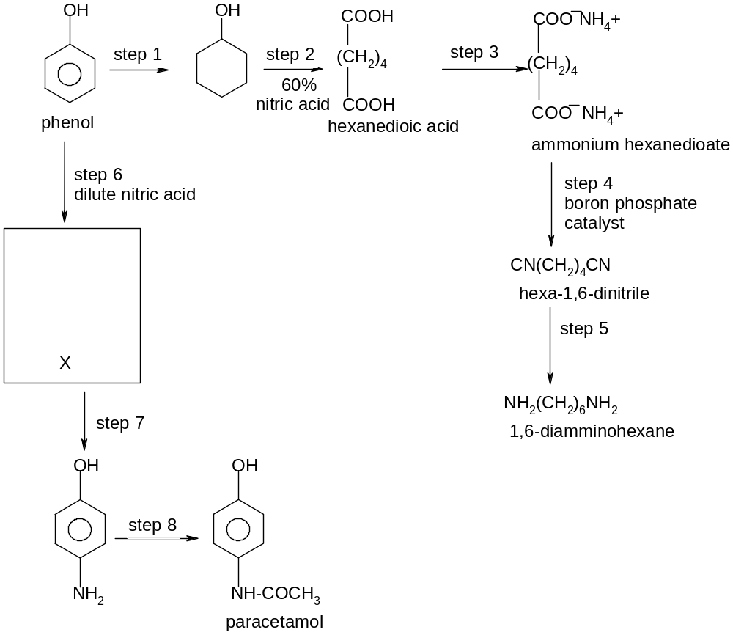
X

(a) |  | Draw the displayed formula of X formed in step 6 in the box provided.
 |  | [2]
(b) |  | Suggest reagents and conditions for steps 1, 3, 5 and 8.
Step

1 …………………………………………………………………………………………

3…………………………………………………………………………………………

5…………………………………………………………………………………………

8…………………………………………………………………………………………

 |  | [4]
(c) |  | Name the types of reactions in steps 2, 4 and 6.
Step

2 …………………………………………………………………………………………

4…………………………………………………………………………………………

6…………………………………………………………………………………………

 |  | [3]
(d) |  | What is unusual about the reaction in step 8?
…………………………………………………………………………………………

…………………………………………………………………………………………

 |  | [1]
 |  | [Total: 10]
6 |  | A cyclic compound, Y is shown below.
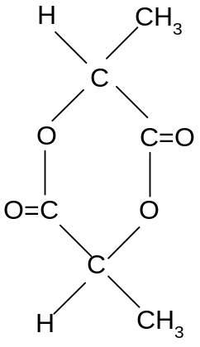

(a) |  | State the functional group in Y
 |  | ………………………………………………………………………………………….
 |  | [1]
(b) |  | Compound Y is warmed with dilute sulphuric acid.
 | (i) | State the type of reaction Y undergoes.
 |  | …………………………………………………………………………………………
 | (ii) | Give the structural formula of the product labelled as Z, of molecular mass 90 formed in reaction b(i).
 |  | [2]
(c) |  | Draw the structures of the organic products formed when Z is
 | (i) | warmed with alkaline iodine.
 | (ii) | reacted with phosphorus pentachloride.
 | (iii) | added to aqueous sodium carbonate.
 |  | [4]
 | (iv) | Write equations for reactions (c)(ii) and (c)(iii).
…………………………………………………………………………………………

…………………………………………………………………………………………

 |  | [2]
(d) |  | Is Z soluble in water? Give a reason for your answer.
…………………………………………………………………………………………

…………………………………………………………………………………………

 |  | [2]
 |  | [Total: 11]

End of Paper

